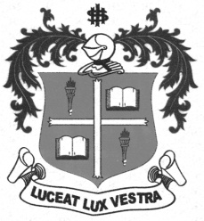
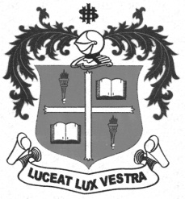
LOYOLA COLLEGE (AUTONOMOUS), CHENNAI – 600 034
B.A. DEGREE EXAMINATION – ENGLISH LITERATURE
SIXTH SEMESTER – APRIL 2012

EL 6600 - HISTORY OF ENGLISH LITERATURE

Date : 16-04-2012 Dept. No. Max. : 100 Marks
Time : 1:00 - 4:00

PART – A

- Identify the following writers by relating them to: (10 × 2 = 20)
- Literary school and movement
- The chief literary form promoted
- Contemporary writers
- Any significant historical/social/political/ideological event. Your answer should not exceed 30 words.

- Spenser
- Earl of Surrey
- Andrew Marvell
- Alexander Pope
- John Bunyan
- Keats
- Tennyson
- Ruskin
- Hardy
10. Hemingway

PART – B

- Answer any FIVE of the following in about 150 words each: (5 × 7 = 35)

11. Identify the main literary events in the Age of Chaucer.
12. Write a note on the University Wits.
13. Discuss the Reformation movement.
14. Bring out the major aspects of Restoration Drama.
15. Consider the Dramatic monologue as a literary form.
16. Evaluate Bernard Shaw as a major dramatist.
17. Show how Science Fiction is becoming a major trend in literature.

18. Describe the characteristic traits of American Poetry.

PART – C

- Answer any THREE of the following in about 250 words each:
- × 15 = 45)
19. Trace the impact of Renaissance on English Literature.
- Attempt an evaluation of Metaphysical poetry.

- Examine in detail the Periodical Essay and its growth.
- Make an assessment of the contribution of Charles Dickens to
British fiction.

- Consider Eugene O’Neill and Tennessee Williams as major American
dramatists.

$$$$$$$

